# **A2: Project Plan & Presentation**

**MyFINtip app - Finance at your fingertips**

MyFINtip is a personal finance management app that offers spending insights, savings strategies, predictive analysis and budgeting recommendations. It achieves this by integrating Open Banking APIs and leveraging machine learning.

**Project Objectives:**

* Develop an AI-driven financial assistant app with spending insights in 6 weeks
* Integrate banking APIs to enable real-time tracking
* Achieve 85% accuracy in expense forecasting
* Launch a beta version with 500 users by the end of month 2
* Ensure GLBA and PSD2 Compliance for Data Security.

**Key Deliverables:**

* Mobile & Web App for finance tracking
* AI-powered budgeting assistant
* Personalized savings & investment recommendations
* Encrypted API integrations with banks
* User-friendly dashboard

**Project Scope:**

* AI-driven budgeting & spending analysis
* Expense categorization & financial insights
* Fraud detection & security features
* Open Banking integration

**Milestones:**

* Project Initiation by March 17th 2025
* AI development: April 26th
* UI/UX development: April 26th
* Backend Development: April 26th
* Testing and Quality Assurance: May 8th
* Deployment and launch: May 11th

**Technical requirements:**

* Python for programming
* ReactNative for app and website development
* Plaid for API integration
* AWS for cloud storage
* AES 256 for data encryption
* Tableau for dashboard

**Limits and Exclusions:**

* It will not execute financial transactions but only provide recommendations.
* The app's accuracy depends on the quality of financial data available from banking APIs.
* The initial version will focus on individual users and not businesses.
* The app will be launched regionally first, with expansion plans to multi-currency based on adoption and regulatory approvals.
* Cryptocurrency not included.

Thus, our aim is to develop and launch the app indigenously within six weeks, ensuring a functional and user-friendly experience. By the end of two months, achieve at least 500 active users, measured through login activity. This user base will serve as reference clients, providing positive feedback to enhance credibility and attract more users. The app will be free for all users initially. In the future, we plan to additionally include a premium plan, generating revenue by executing financial recommendations and investing on behalf of users.

**Reasons for conducting this project:**

* Enhancing Financial Literacy with AI for Low-Income Groups
* Affordable Financial Planning Solutions
* Improved Risk Mitigation During Economic Instability
* Driving Digital Transformation in Finance

**Delimitation of the project:**

The project currently serves only U.S. customers and operates in a single currency. It provides recommendations on mutual funds and stock investments, refinancing loan savings, strategies to improve credit scores, tax optimization, fraud detection, and retirement planning.

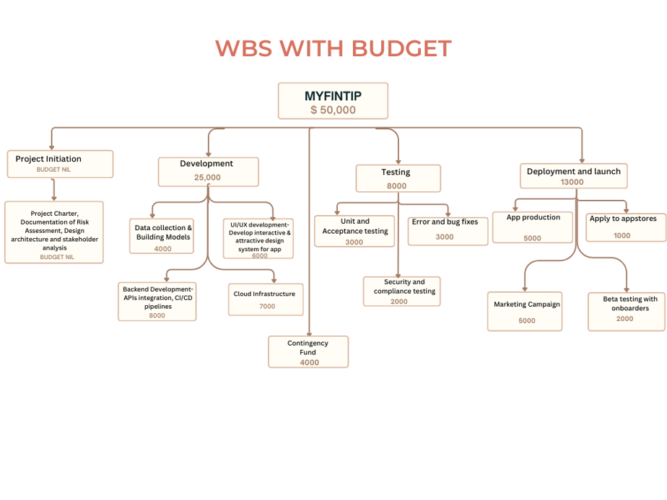

**STAKEHOLDER ANALYSIS:**

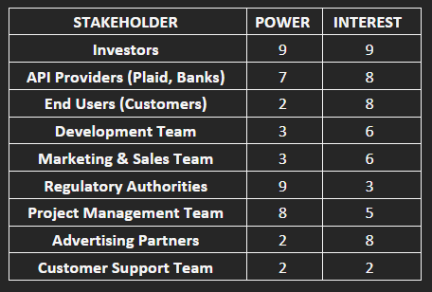 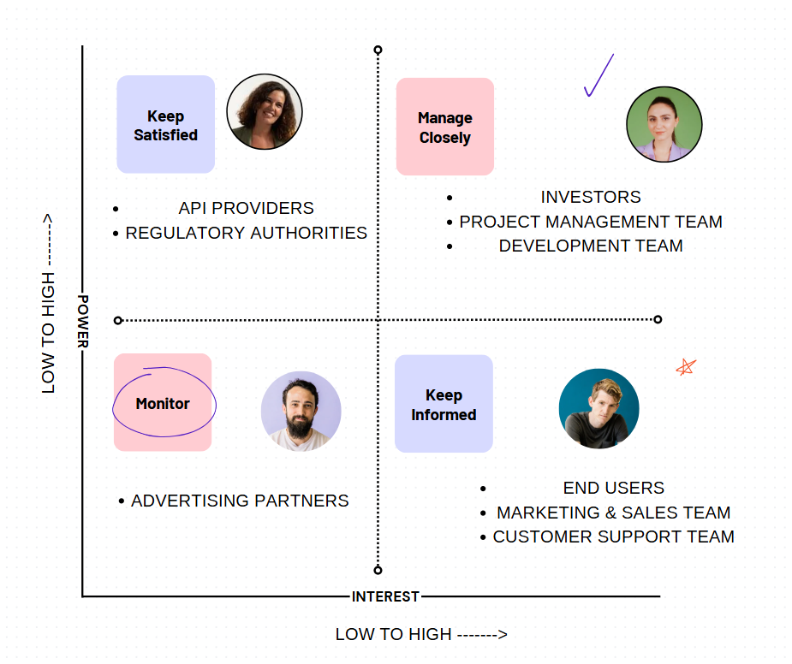

**DETAILED WBS:**

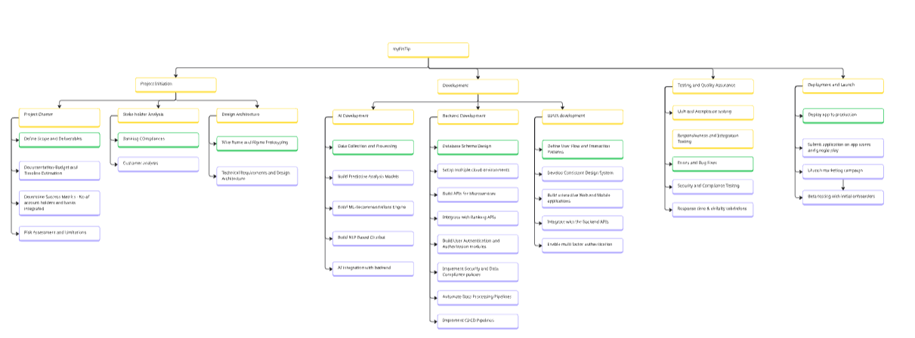

**GANTT CHART:**

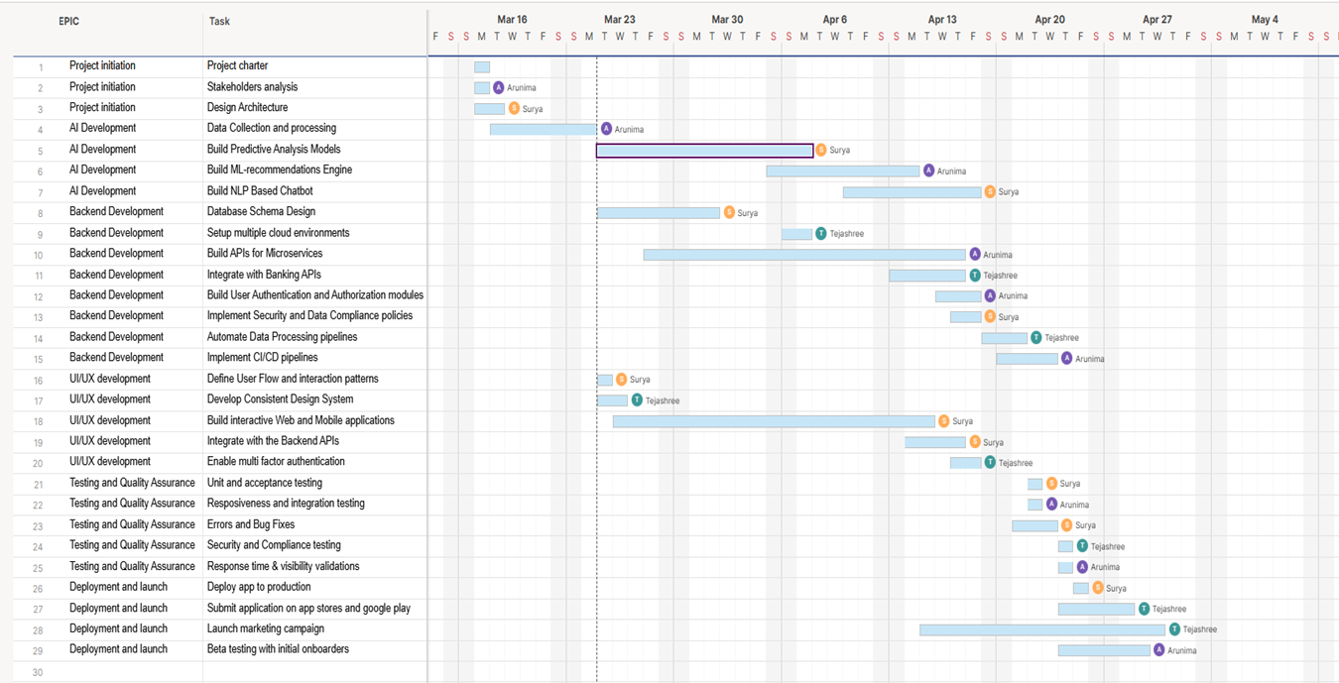

**RISK BREAKDOWN STRUCTURE**

|  |  |  |  |  |  |  |  |
| --- | --- | --- | --- | --- | --- | --- | --- |
| **Identified risk** | **Risk Description** | **Cost** | **Time** | **Scope** | **Quality** | **Probability of occurrence (%)** | **Probable impact** |
| 1 | AI model training is delayed due to data inconsistencies | 2 | 2 | 1 | 1 | 40% | 2.4 |
| 2 | Incompatible with banking APIs because of regulatory constraints | 2 | 1 | 1 | 2 | 40% | 2.4 |
| 3 | What if the app is rejected from Apple/Google stores? | 2 | 2 | 1 | 1 | 10% | 0.6 |
| 4 | APP Prediction at < 85% Accuracy | 2 | 2 | 3 | 3 | 20% | 2 |
| 5 | Beta user adoption is low | 1 | 2 | 1 | 1 | 30% | 1.5 |
| 6 | Open Banking API approval delays | 1 | 2 | 1 | 1 | 50% | 2.5 |
| 7 | Attacks on financial data related to cybersecurity | 3 | 1 | 2 | 3 | 70% | 6.3 |
| 8 | Cloud infrastructure failures that lead to system downtime | 2 | 1 | 1 | 1 | 30% | 1.5 |
| 9 | Delays to the project timeline due to supply or political issues | 2 | 2 | 1 | 2 | 20% | 1.4 |

* 1- low risk, 2- medium, 3-high risk

**RISK RESPONSE REGISTRY for probable top risks**

|  |  |  |  |  |
| --- | --- | --- | --- | --- |
| **Risk Description** | **Responsible** | **Risk Response Strategy** | **Contingency Plan** | **Additional cost($)** |
| AI model training is delayed due to data inconsistencies | Surya | Accept | Use synthetic data for space testing; Meanwhile clean the and validate data before training | 500 |
| Incompatible with banking APIs because of regulatory constraints | Tejashree | Accept | Have fall-back APIs; Engage compliance expert early | 1000 |
| Open Banking API approval delays | Tejashree | Mitigate | Approval can take longer than expected. Submit waste analysis as early as possible. Validate early. Remain closely involved with regulatory agencies | 500 |
| Attacks on financial data related to cybersecurity | Tejashree | Avoid | Implement strong security measures; more frequent penetration testing and frequent audit checks | 1000 |

**SPRINT CYCLE:**

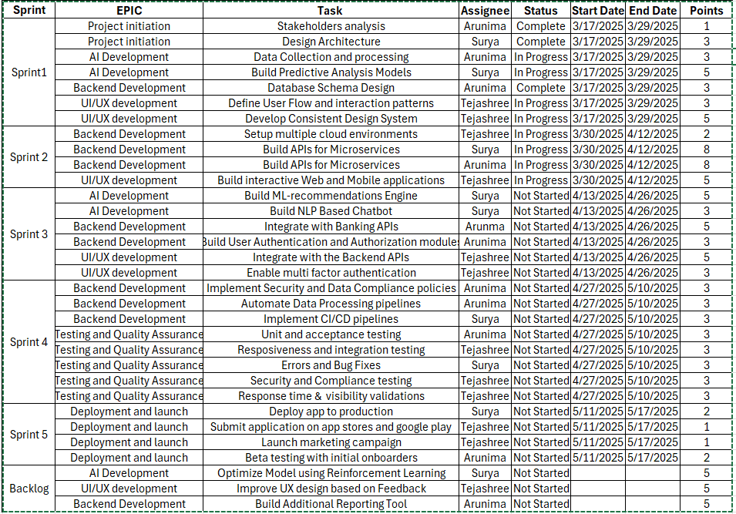

Currently the backlog is minimal; we are expecting more tasks as we progress into further sprints, and further tasks based on feedback post initial testing would be added.